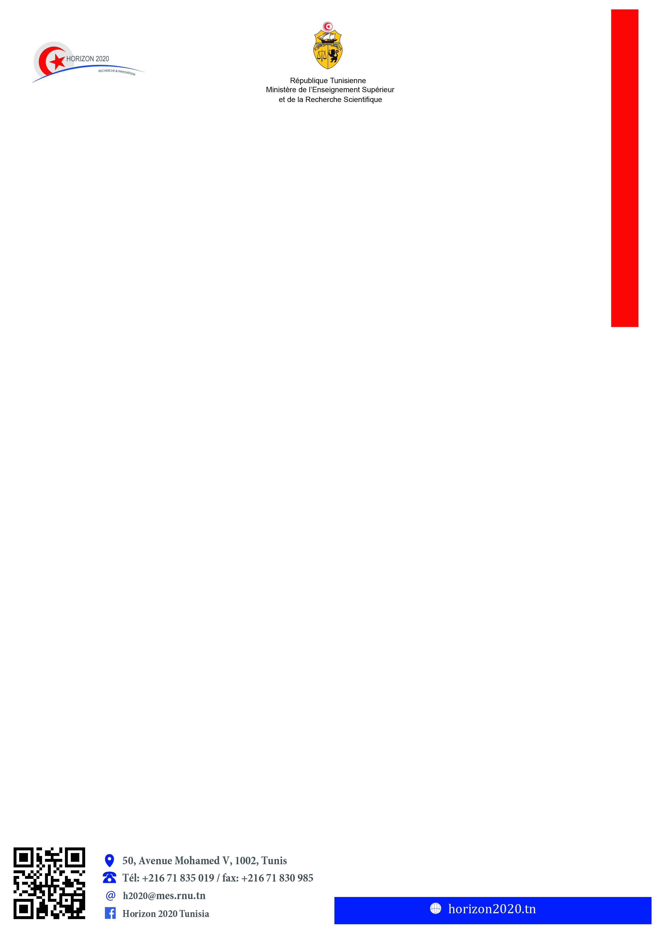

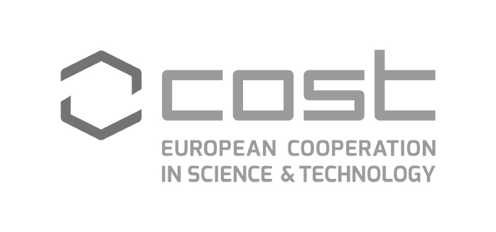

**Awareness Day**

**European Cooperation in Science and Technology**

**COST**

The Ministry of Higher Education and Scientific Research (MHESR) - Management Unit of R&I Program Horizon 2020 - is co-organizing with the European **Co**operation in **S**cience and **T**echnology [**COST**], the **first COST event** in Tunisia for the benefit of R&I community.

The European **Co**operation in **S**cience and **T**echnology [**COST**] is a funding organization for the creation of research networks, called **COST Actions**. These networks, **in all scientific domains,** are highly **interdisciplinary** and offer **an open space for collaboration**. They are **multi-stakeholder**, often involving the private sector, policymakers as well as civil society.

**COST** receives EU funding under the various research and innovation framework programs, such as Horizon 2020 and the Novelty in Horizon Europe is the full integration of **COST** under the cross-cutting thematic **Widening Participation & Spreading Excellence**.

COST funds **networks of excellence**, where knowledge is **freely shared** among all types of specialists, from the traditional academic freedom for curiosity-driven research to technical and market-oriented solutions. Through its **open networking instruments**, COST is promoting brain circulation, enabling the **multi-directional** mobility of **skilled people** between countries.

Researchers, Policymakers, Public and Private enterprises, Civil society:

**👉** Do you want to discover the opportunities offered by COST ?

**👉** Do you want to integrate a funded COST action without worrying about the design phase ?

**👉** Do you want to attend an event and leave with one or more COST Actions in hands ?

**👉** Do you want to benefit from COST activities : workshops, conferences, working group meetings, training schools, short-term scientific missions… ?

**👉** Do you want to develop an international R&I career ?

*We are looking forward to welcoming you in COST Awareness Day, to embark on an exciting COST experience!*

|  |  |  |
| --- | --- | --- |
| ***e-signed***  ***Prof. Olfa ZERIBI BEN SLIMANE***  Director General – UGPE H2020 | ***e-signed***  ***Mrs. Amani MAHJOUBI CHARRAD***  COST National Correspondent | ***e-signed***  ***Dr. Ronald DE BRUIN***  Director of COST Association |

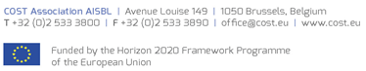



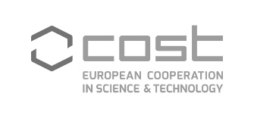

**Awareness Day**

**European Cooperation in Science and Technology**

**COST**

**20 February 2020**

*Venue: The City of Science, Tunis*

|  |  |
| --- | --- |
| Agenda | |
| 8:30 – 09:00 | **Registration & Welcome Coffee** |
|  | **High Level Welcome address**  *Moderator*: **Prof. Olfa ZERIBI BEN SLIMANE**, DG European R&I Program Horizon 2020 - MHESR |
| 9:00 – 09:30 | **Dr. Ronald DE BRUIN,** Director of COST Association |
| **His Excellency Mr. Ridha BEN MOSBAH,** Ambassador of Tunisia in Brussels |
| **His Excellency Mr. Patrice BERGAMINI,** EU Ambassador in Tunisia (Tbc) |
| **Mr. Hatem BEN SALEM,** Minister of Higher Education and Scientific Research |
|  | **Plenary session 1**  *Moderator*: **Mr. Malek KOCHLEF,** DG International Cooperation - MHESR |
| 09:30 – 09:55 | COST – European Cooperation in Science and Technology, Introduction to the COST Framework Programme**, Dr. Ronald DE BRUIN**, Director of COST Association |
| 09:55 – 10:10 | COST – How to get involved in COST?**, Mr. Bart VEYS,** Policy Officer - COST Association |
| 10:10 – 10:20 | **Q&A** |
|  | **Plenary session 2**  *Moderator*: **Prof. Samia CHARFI KADDOUR,** DG Scientific Research - MHESR |
| 10:20 – 10:35 | The participation of Tunisian R&I actors in COST actions: capacities and perspectives,  **Mrs. Amani MAHJOUBI CHARRAD**, COST National Correspondent |
| 10:35 – 11:00 | **Testimonials of Tunisian researchers involved in COST Actions**  **Dr. Leila KTARI,** National Institute of Marine Sciences and Technologies  [**Prof. Slim**](https://www.cost.eu/actions/CA17107/228257) **TOUNSI,** DG **-** Center of Biotechnology of Sfax |
| 11:00 – 11:10 | **Q&A** |
| 11:10 – 11:30 | **Networking Coffee-break** |
|  | **Workshop session**  *Moderator*: **Mrs. Amani MAHJOUBI CHARRAD,** COST National Correspondent  Management Unit of European R&I Program Horizon 2020 - MHESR |
| 11:30 – 12:30 | **How to participate in COST action?** COST representatives |
|  | **Side Event** (*Requires an invitation*) |
| 12:30 – 14:00 | **High Level Meeting:** COST Direction & MHESR - Research Pole |

